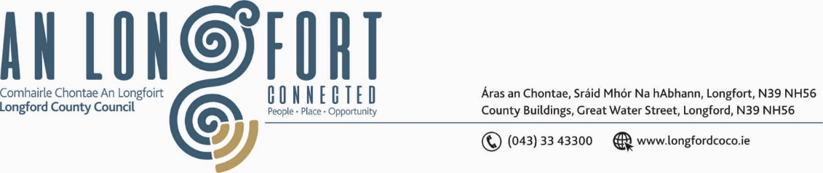

***BALLYMAHON MUNICIPAL DISTRICT***

***Please note meeting will be held in Ballymahon Library.***

**21 September 2023.**

**To: Each Member of Ballymahon Municipal District.**

**Dear Member,**

You are requested to attend a Meeting of Ballymahon Municipal District to be held

**in Ballymahon Library** on **Thursday 28 September 2023 at 4pm** to transact business, as set out on the agenda hereunder.

**Yours sincerely**,

_______________

**Claire McNabola,**

**Meetings Administrator.**

**AGENDA**

Prayer before meeting.

1. Confirmation of Minutes
2. Ballymahon Municipal District Committee Meeting held on the 27 July 2023 – enclosed.
3. Ballymahon Municipal District Meeting held on the 27 July 2023 – enclosed.

**2.** Matters arising from Minutes

**3.** Declaration of Interest by Members

**4**. Management Report - enclosed

**5.** To approve a Statement of Consistency of the Draft Longford Local Economic and Community Plan 2023 - 2029 with the following:-

1. The core strategy and the objectives of the Longford County Development Plan 2021-2027;
2. The Eastern & Midland Regional Assembly Regional Spatial & Economic Strategy 2019 - 2031;
3. The economic and community elements of the Draft Local Economic and Community Plan are consistent with each other.

**6.** ESB Community Benefit Package

**7.** Notices of Motions, submitted by Councillors, as listed hereunder –

**Councillor Mark Casey**

That Longford County Council reinstates the Lollypop person at school times in Lanesborough in the interest of child safety.

**Councillor Paul Ross**

1. I call on Irish Water to properly resurface the Bracklyn Road in Edgeworthstown following the works on the road in recent months.
2. I call on Longford Co Council to apply for a low cost safety scheme at Crossea, Ardagh on the N55 in light of the high number of collisions at this section of road